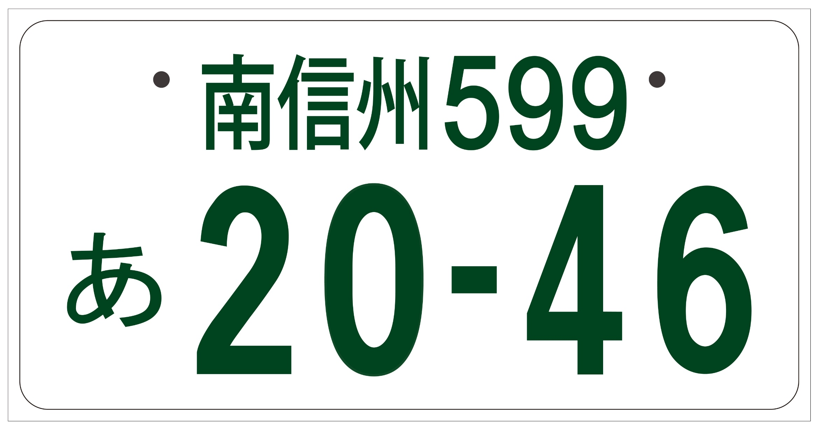

|  |  |
| --- | --- |
| 応募者名 |  |